Monday Lecture

Invented in 1995, originally known as LiveScript. Known as ECMAScript.

* ECMAScript is abbreviated as ES
* Early versions of ECMAScript used the ES abbreviation
* ES6 or ECMA2015
* JavaScript destructuring allows extracting data from object data types (arrays, objects, and newer EDS6 types maps and sets) into their own variables using a simple syntax
  + an array is an object
  + objects have properties and methods
* creating object, example with property variables
* object destructing: data type { list of variables} = object
* variables can be renamed
* or given default values if not defined
* default values do not apply to null, false or 0

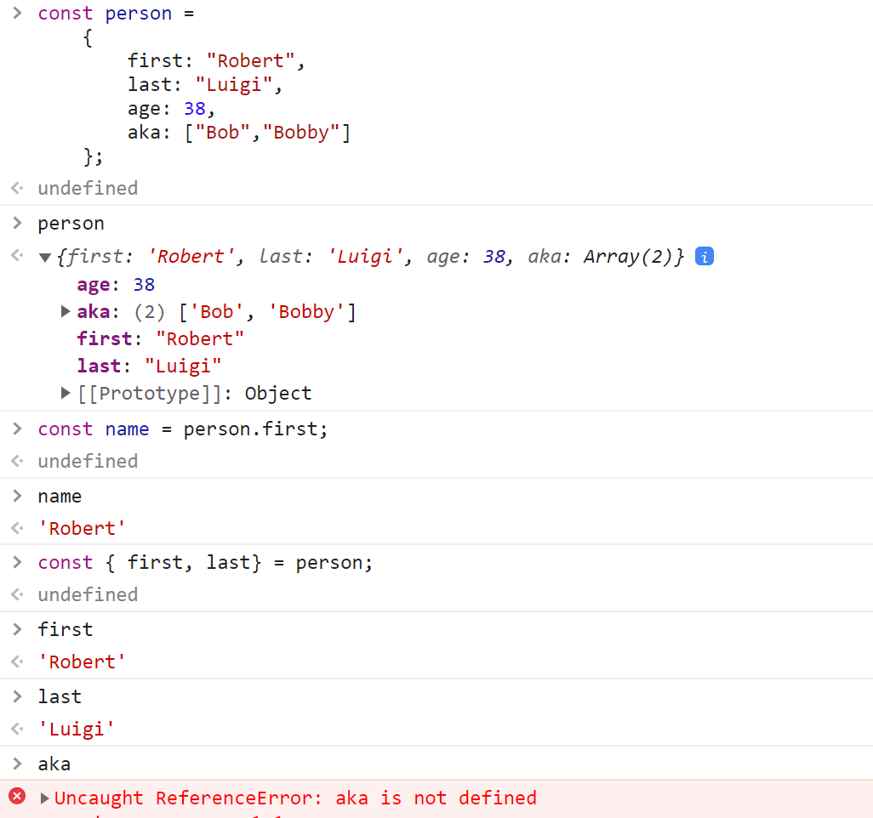

Array destructuing uses the array square bracket syntax and array position (index) to assign variables

* array items can be skipped

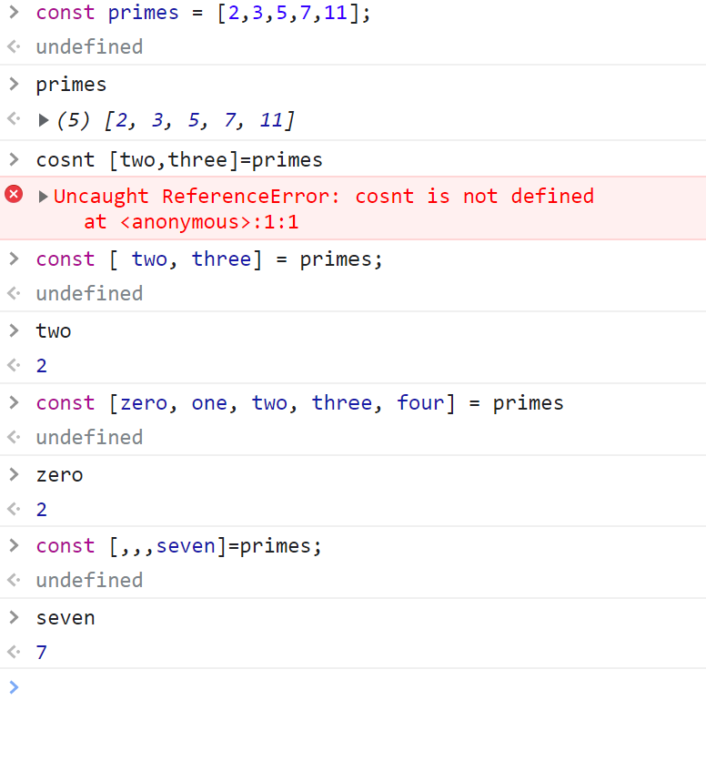

Modularization: reduced code into smaller more manageable components

Complexity reduction: smaller components means reduced individualized component complexity

Encapsulation: isolates functionality and programming required to support that functionality, including variables to include components

Debugging smaller components are easirer to debug and easier to code.

Let and const

* block level scope
* global: defined outside of any block level scope
* scope: defined within a block using curly braces
  + Functions
  + Conditions
  + Loops
  + Arbitrary/ad hoc blocks

Node moduelses

* Module file creates a module.exports object
* A module code is encapsulated within a single file, and exported for use by another file

Importing modules:

* Only import the items needed from the code module

Wednesday Lecture

Normal function

Function foo (parameter) { }  
Anonymous functions, used as a callback

Function (parameter) { }

Function expressions, using anonymous functions

Const foo = function (parameter) { }

Parameters => function body

Function body can implicit return or explicit return

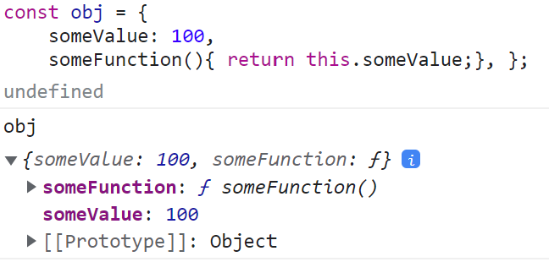

Explicit Return Arrow Functions

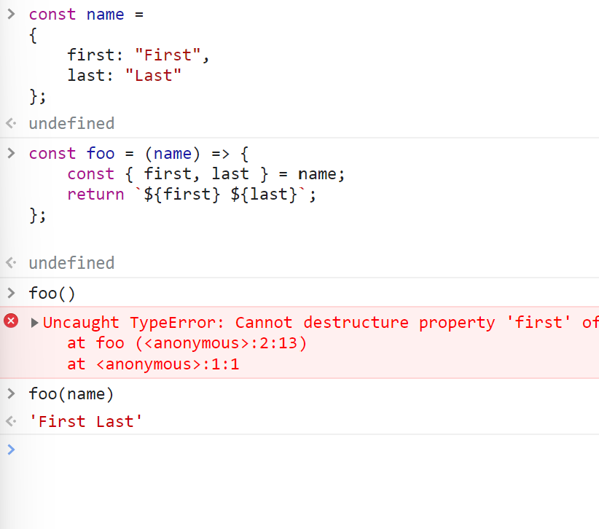

Arrow Functions as Methods

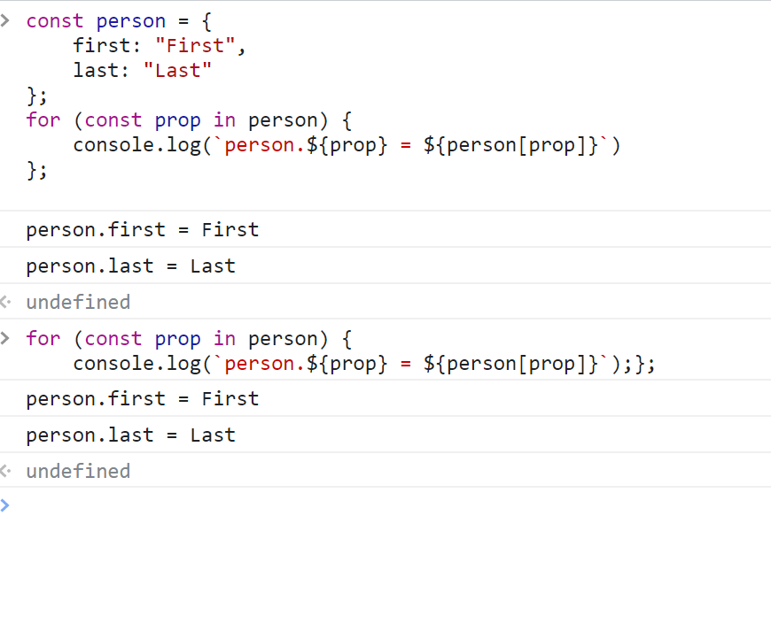

For array loop

Default parameters:

-defaults simplified code,

-parameters may have default values

Ellipsis:  
default destructure values:

The destructuring syntax also supports default values

Ellipsis:

Rest: collect or gather object elements

Spread: spread or scatter object elements

Red white blue example

for in loops